Supplementary methods, tables and figures for Oliver et al. “Very limited dispersal and differing evolutionary trajectories across closely proximate continental and insular regions in a widespread lizard radiation (Gehyra).”

Supplemental Methods

Biogeographical analyses

Gehyra biogeography was discretized into six areas in order to capture the major coarse-scale features of the clade’s geographic distribution, while limiting computation time over a series of inferential models. The six areas were abbreviated as follows.

O = Australia
N = New Guinea
W = Wallacea
E = East Melanesia
P = Pacific
A = Asia

The dated phylogeny of 96 Gehyra taxa (described species, or genetically isolated populations thought to be likely species/lineages) was displayed in ladderized format in FigTree and saved to Newick format. We constructed a geographic ranges text file coding each taxon as present or absent in each of the 6 areas. The maximum number of areas occupied was 4 (by G. insulana, found in N, W, E, P). Nevertheless, while constructing the list of possible geographic states in the states list (i.e., the list of possible ranges), we set max_range_size to 6, to allow maximum flexibility. The null range (0 areas occupied) was also allowed in the state space (Massana et al. 2015). This resulted in 2^6=64 possible ranges in the state space.

BioGeoBEARS analysis

An initial analysis was conducted in the R package BioGeoBEARS (Matzke 2013) version 1.1.4 (Matzke 2025). Six common base models were compared: DEC (Ree & Smith 2008); DIVALIKE, a likelihood implementation of the events allowed in the parsimony DIVA program (Ronquist 1997); and BAYAREALIKE, a likelihood implementation of the BayArea model (Landis et al. 2013), plus “+J” variants of these models, which add the possibility of jump dispersal/founder-event speciation at cladogenesis (Matzke 2014; for a defense of the +J model variant against criticisms, see Matzke 2022). DEC, DIVALIKE, and BAYAREALIKE make different assumptions about how cladogenesis (speciation) can change geographic ranges at nodes (see Figure 1 of Matzke 2013), and +J models use a free parameter, j, to measure the relative weight of jump dispersal events at cladogenesis versus the other cladogenetic range inheritance events allowed under the base model.

Parameters were inferred for each model using Maximum Likelihood (ML) inference. Model fit was statistically compared using AICc and AICc weights (Franklin et al. 2001; Burnham & Anderson 2002; Anderson 2008).

Testing the effect of including lineage extinction in biogeographical models using PhyBEARS.jl

A legitimate criticism of the biogeographical models implemented in BioGeoBEARS and previous software packages is that they take the phylogenetic tree as complete, i.e. the only cladogenesis events that can change geographic ranges are the speciation events in the observed tree. This amounts to a Yule process assumption, i.e. a “pure birth” process with 0 extinctions (Matzke 2022), which is extremely unlikely to represent reality (Marshall 2017). While a simulation study suggested that ignoring extinction may not dramatically bias the inference of ancestral geographic ranges, at least with random extinction (Matzke 2014), newer technology enabling SSE models (state-dependent speciation/extinction models; Maddison et al. 1997) to be run on large biogeographical state spaces allows the possibility of lineage extinction being added to biogeographical modes. The Julia package PhyBEARS.jl (Matzke and Bland, 2024a, 2024b) implements BioGeoBEARS models in a full cladogenesis SSE (ClaSSE; Goldberg & Igic 2011) framework. PhyBEARS.jl uses the Julia library DifferentialEquations.jl (Rackauckas & Nie 2017) to calculate SSE likelihoods using Ordinary Differential Equation (ODE) solvers designed for large state spaces (typically CVODE_BDF). The runtimes for ML inference using this Julia implementation of the ODE SSE calculations are typically similar or slightly faster than the simpler non-ODE BioGeoBEARS calculations in R using matrix exponentiation, and much faster that R’s ODE solving libraries (Bland 2024).

Basic validation of PhyBEARS calculations and estimates against BioGeoBEARS and simulated data was conducted by Bland (2024), as well as 511 unit tests implemented in the PhyBEARS.jl tests directory (Matzke and Bland, 2024a). However, although PhyBEARS.jl makes it feasible to include extinction in the likelihood calculations for large problems, accurate inference of extinction rates from molecular phylogenies is still a very difficult problem (Marshall 2017; Louca & Pennell 2021; Legried & Terhorst 2023). However, it is still useful to conduct sensitivity tests to see biogeographical inference is substantially changed by including lineage extinction.

For the Gehyra dataset, we implemented the standard DEC and DEC+J models in PhyBEARS, first with a Yule process (lineage extinction set to 0). Then we created a series of model variants with the lineage extinction set to be a free parameter, or with the extinction rate constrained to equal the speciation rate (this reflects the typical rough balance in the fossil record; Marshall 2017).

An alternative model tested was to set the extinction rate is set to match e, the rate of range loss, with the model set up so that (1) the null range was not an allowed state in the state space, (2) the extinction rate for a lineage occupying multiple areas was 0.0, and (3) extinction occurred only when an e range contraction event occurred in a single-area range.

Biogeographical Results

The statistical model comparison of BioGeoBEARS models are found in Table S2. A comparison of PhyBEARS models is shown in Table S3. DEC+J dominates in both model sets, but in PhyBEARS models, likelihood and AICc differences were small between the DEC+J model variants, with all of them being in the credible set except for model 10, where the single-area extinction rate was set to equal the birth rate.

The AICc-best model was PhyBEARS Model 12, a DEC+J+birth-death model where both e and deathRate are constrained to equal d, the range-expansion rate. However, this model (AICc weight 46.8%) was only slightly better than standard DEC+J (AICc weight 42.8%) implemented in PhyBEARS (termed DEC+J+Yule, indicating that standard DEC+J ignores the possibility of lineage extinction). Inference of the geographic history under Model 12 (Figure S5) was similar to that under standard DEC+J. This probably occurred due to the low inferred d=e=deathRate parameter (0.0015, compared to an inferred speciation rate of 0.17 events per million years). The lowness of these parameters in DEC+J models suggests that that the observed geographic ranges can mostly be explained by cladogenetic jump events, and that postulating range loss and lineage extinction is not particularly necessary to explain the data under consideration (note that this is different than saying these low rates are biologically plausible).

To get a sense of how much a realistically high extinction rate could change biogeographic inference, the PhyBEARS ancestral range estimates for Models 4 and 10 (Figures S6–7) (in both, deathRate was constrained to equal birthRate) can be compared to the results above. Forcing a high extinction rate into the model results in higher uncertainty at many nodes, especially deep nodes, but overall, most nodes have the same plurality-favoured range estimates.

References

Anderson, David R. (2008). Model Based Inference in the Life Sciences: A Primer on Evidence. New York, Springer. doi: 10.1007/978-0-387-74075-1

Bland, Wallis Miyuki (2024). Improving realism in biogeographic simulation and inference with state-dependent speciation and extinction models using GPlates palaeogeography and the Julia programming language. Ph.D. thesis, School of Biological Sciences, University of Auckland. Published by: ResearchSpace@Auckland. pp. 1-203. https://hdl.handle.net/2292/70305
Burnham, Kenneth P.; Anderson, David R. (1998, first edition; 2002, second edition). Model Selection and Multimodel Inference: A Practical Information-Theoretic Approach. New York, Springer. doi: 10.1007/b97636

Franklin, Alan B.; Shenk, Tanya M.; Anderson, David R.; Burnham, Kenneth P. (2001). "Statistical Model Selection: An Alternative to Null Hypothesis Testing." Modeling in Natural Resource Management: Development, Interpretation, and Application. Edited by T. M. Shenk and A. B. Franklin. Washington, Island Press: 75-90.

Landis, Michael J., Matzke, Nicholas J.; Moore, Brian R.; Huelsenbeck, John P. (2013). "Bayesian Analysis of Biogeography when the Number of Areas is Large." Systematic Biology, 62(6), 789-804. http://dx.doi.org/10.1093/sysbio/syt040

Legried, Brandon; Terhorst, Jonathan (2023). Identifiability and inference of phylogenetic birth-death models. Journal of Theoretical Biology, 568:111520. doi: 10.1016/j.jtbi.2023.111520

Louca, S.; Pennell M. W. (2021). Why extinction estimates from extant phylogenies are so often zero. Current Biology, 31(14):3168-3173.e4. doi: 10.1016/j.cub.2021.04.066

Goldberg, E. E., & Igic, B. (2012). Tempo and mode in plant breeding system evolution.
Evolution, 66(12), 3701-3709. doi:10.1111/j.1558-5646.2012.01730.x

Maddison, W. P., Midford, P. E., & Otto, S. P. (2007). Estimating a binary character's effect on speciation and extinction. Systematic Biology, 56(5), 701-710. doi:10.1080/10635150701607033

Marshall, Charles R. (2017). Five palaeobiological laws needed to understand the evolution of the living biota. Nature Ecology & Evolution. 1(6):165. doi: 10.1038/s41559-017-0165.

Massana, Kathryn A.; Beaulieu, Jeremy M.; Matzke, Nicholas J.; O'Meara, Brian C. (2015). Non-null Effects of the Null Range in Biogeographic Models: Exploring Parameter Estimation in the DEC Model. bioRxiv, 026914. http://dx.doi.org/10.1101/026914

Matzke, Nicholas J. (2013). "Probabilistic historical biogeography: new models for founder-event speciation, imperfect detection, and fossils allow improved accuracy and model-testing." Frontiers of Biogeography, 5(4), 242-248. https://doi.org/10.21425/F5FBG19694

Matzke, Nicholas J. (2014). "Model Selection in Historical Biogeography Reveals that Founder-event Speciation is a Crucial Process in Island Clades." Systematic Biology, 63(6), 951–970. http://dx.doi.org/10.1093/sysbio/syu056

Matzke, Nicholas J. (2022). Statistical comparison of DEC and DEC+J is identical to comparison of two ClaSSE submodels, and is therefore valid. Journal of Biogeography, 49(10), 1805-1824. doi: 10.1111/jbi.14346

Matzke, N. J., & Bland, W. (2024a). PhyBEARS.jl: Phylogenetic biogeography SSE models for large state spaces (Version 1.0). https://github.com/nmatzke/PhyloBits.jl

Matzke, N. J., & Bland, W. (2024b). PhyloBits.jl: Phylogenetic tree tables and other
phylogenetic utilities (Version 1.0). https://github.com/nmatzke/PhyloBits.jl

Matzke, Nicholas J. (2025) BioGeoBEARS: BioGeography with Bayesian (and likelihood) evolutionary analysis in R Scripts. Version 1.1.4. https://github.com/nmatzke/BioGeoBEARS/

Rackauckas, C., & Nie, Q. (2017). DifferentialEquations.jl – A Performant and Feature-Rich Ecosystem for Solving Differential Equations in Julia. Journal of Open Research Software, 5(1). doi:10.5334/jors.151

Ree, R. H., & Smith, S. A. (2008). Maximum likelihood inference of geographic range evolution by dispersal, local extinction, and cladogenesis. Systematic Biology, 57(1), 4-14. doi:10.1080/10635150701883881

Ronquist, F. (1997). Dispersal-vicariance analysis: A new approach to the quantification of historical biogeography. Systematic Biology, 46(1), 195-203. doi:10.2307/2413643

Table S1. Area state and maximum body size data for species and OTUs of Gehyra included in analyses.

species grp | species/OTU | Region_broad | Region_fine | maxSVL | SVL datasource
australis grp | arnhemica | Continental | Australia | 68.2 | Original description
australis grp | australis | Continental | Australia | 68.1 | Recent redescription
australis grp | borroloola | Continental | Australia | 65 | Shai Meiri body size database
australis grp | calcitectus | Continental | Australia | 77.1 | Original description
australis grp | catenata | Continental | Australia | 55 | Shai Meiri body size database
australis grp | chimera | Continental | Australia | 73.7 | Original description
australis grp | CYsp1 | Continental/Insular | Australia, New_Guinea | 72 | PMO measures
australis grp | CYsp2 | Continental | Australia | na
australis grp | dubia | Continental | Australia | 65 | Wilson and Swan 2020
australis grp | electrum | Continental | Australia | 50 | Original description
australis grp | gemina | Continental | Australia | 68.9 | Original description
australis grp | Groote | Continental | Australia | 57 | PMO measures
australis grp | ipsa | Continental | Australia | 94.9 | Wilson and Swan 2020
australis grp | koira | Continental | Australia | 80.4 | Oliver et al. 2019
australis grp | lapistola | Continental | Australia | 74.2 | Oliver et al. 2019
australis grp | lauta | Continental | Australia | 83.1 | Original description
australis grp | pamela1 | Continental | Australia | 70 | Wilson and Swan
australis grp | robusta1 | Continental | Australia | 75 | Wilson and Swan
australis grp | robusta2 | Continental | Australia | na
australis grp | robusta3 | Continental | Australia | na
australis grp | robusta4 | Continental | Australia | na
australis grp | robusta5 | Continental | Australia | na
membranacruralis grp | aquilonia | Insular | New_Guinea | 134 | Original description
membranacruralis grp | chrysopeleia | Insular | New_Guinea | 142 | Original description
membranacruralis grp | membranacruralis | Insular | New_Guinea | 131 | PMO measures
mutilata grp | fehlmani | Asia | Asia | 51 | Das 2010
mutilata grp | insulana | Insular | New_Guinea, Wallacea, East Melanesia | 60 | Shai Meiri body size database
mutilata grp | mutilata | Insular, Continental | Asia, Wallacea | 67 | Shai Meiri body size database
oceanica grp | baliola | Insular | New_Guinea | 99 | PMO measures
oceanica grp | barea | Insular | New_Guinea, Wallacea | 98 | PMO measures
oceanica grp | brevipalmata | Insular | Pacific | 86 | PMO measures
oceanica grp | cf_brevipalmata | Insular | New_Guinea | 80 | PMO measures
oceanica grp | cf_lampei | Insular | New_Guinea | 61.3 | PMO measures
oceanica grp | corona | Insular | East_Melanesia | 95 | Original description
oceanica grp | lampei | Insular | New_Guinea | na
oceanica grp | louisadensis | Insular | New_Guinea | 83 | Original description
oceanica grp | maculocincta | Insular | New_Guinea | 70 | Original description
oceanica grp | marginata | Insular | Wallacea | 142 | PMO measures
oceanica grp | oceanica1 | Insular | East_Melanesia, Pacific | 102 | W Beckon PhD thesis
oceanica grp | oceanica2 | Insular | East_Melanesia | na
oceanica grp | oceanica3 | Insular | New_Guinea | 87.5 | Fred Kraus data
oceanica grp | oceanica4 | Insular | East_Melanesia | 83 | W Beckon PhD thesis
oceanica grp | oceanica5 | Insular | East_Melanesia | na
oceanica grp | oceanica6 | Insular | East_Melanesia | 84 | Ken Aplin measures
oceanica grp | oceanica7 | Insular | Pacific | 85.4 | W Beckon PhD thesis
oceanica grp | oceanica8 | Insular | East_Melanesia | 76 | PMO measures
oceanica grp | Peleng | Insular | Wallacea | na
oceanica grp | Solomons | Insular | East_Melanesia | 71 | PMO measures
variegata grp | capensis | Continental | Australia | 46 | Original description
variegata grp | crypta | Continental | Australia | 56.5 | original description
variegata grp | einasleighensis | Continental | Australia | 41 | Original description
variegata grp | fenestrula | Continental | Australia | 56 | Wilson and Swan 2020
variegata grp | finipunctata | Continental | Australia | 56 | Original description
variegata grp | girloorloo | Continental | Australia | 48 | Original description
variegata grp | granulum | Continental | Australia | 45.9 | Original description
variegata grp | incognita | Continental | Australia | 52 | Original description
variegata grp | kimberleyi | Continental | Australia | 61 | Wilson and Swan 2020
variegata grp | lazelli | Continental | Australia | 59 | Recent redescription
variegata grp | macra | Continental | Australia | 73.5 | Recent redescription
variegata grp | media | Continental | Australia | 50 | Wilson and Swan 2020
variegata grp | micraL | Continental | Australia | 46.6 | Original description
variegata grp | micraU | Continental | Australia | na
variegata grp | minuta | Continental | Australia | 45 | Original description
variegata grp | montium | Continental | Australia | 51 | Wilson and Swan 2020
variegata grp | moritzi | Continental | Australia | 49 | Original description
variegata grp | multiporosa | Continental | Australia | 55 | Wilson and Swan 2020
variegata grp | nana1 | Continental | Australia | 55.3 | Recent redescription
variegata grp | nana2 | Continental | Australia | na
variegata grp | nana4 | Continental | Australia | na
variegata grp | nanamulti | Continental | Australia | na
variegata grp | occidentalis_OR | Continental | Australia | 69 | R Laver thesis
variegata grp | occidentalis-KL | Continental | Australia | 76 | Wilson and Swan 2020
variegata grp | occidentalis-YI | Continental | Australia | 64.2 | Laver thesis
variegata grp | ocellata | Continental | Australia | 49 | Original description
variegata grp | paranana | Continental | Australia | 54.8 | Original description
variegata grp | peninsularis | Continental | Australia | 48.5 | Original description
variegata grp | pilbara | Continental | Australia | 55 | Wilson and Swan 2020
variegata grp | pluraporosa | Continental | Australia | 46.3 | Original description
variegata grp | polka | Continental | Australia | 61 | Original description
variegata grp | pseudopunctata | Continental | Australia | 57.8 | Original description
variegata grp | pulingka | Continental | Australia | 49 | Original description
variegata grp | punctata | Continental | Australia | 65 | Wilson and Swan 2020
variegata grp | purpurascens | Continental | Australia | 64 | Wilson and Swan 2020
variegata grp | spheniscus | Continental | Australia | 46 | Wilson and Swan 2020
variegata grp | unguiculata | Continental | Australia | 39 | Original description
variegata grp | variegata | Continental | Australia | 49 | Wilson and Swan 2020
variegata grp | versicolor | Continental | Australia | 54 | Wilson and Swan 2020
variegata grp | xenopusBI | Continental | Australia | 69.8 | R Laver thesis
variegata grp | xenopusMP | Continental | Australia | 78 | R Laver thesis
variegata grp | xenopusN | Continental | Australia | 74.1 | R Laver thesis
variegata grp | xenopusS | Continental | Australia | 81.2 | R Laver thesis
vorax grp | georgpotthasti | Insular | East_Melanesia | 142 | Original description
vorax grp | rohan | Insular | East_Melanesia | 150 | PMO measures
vorax grp | vorax1 | Insular | East_Melanesia | 155 | PMO measures
vorax grp | vorax2 | Insular | East_Melanesia | 129 | PMO measures

Table S2. Results of statistical model comparison of the 6 standard BioGeoBEARS models. For key, see Table S5.

Model | LnL | k | d | e | j | AICc | AICc weight
DEC | -83.54 | 2 | 0.0042 | 1.00E-12 | 0 | 171.2 | 0.0035
DEC+J | -76.83 | 3 | 0.002 | 1.00E-12 | 0.0076 | 159.9 | 0.99
DIVALIKE | -88.13 | 2 | 0.0056 | 1.00E-12 | 0 | 180.4 | 3.6E-05
DIVALIKE+J | -83.09 | 3 | 0.0035 | 1.00E-12 | 0.0072 | 172.5 | 0.0019
BAYAREALIKE | -116 | 2 | 0.0035 | 0.038 | 0 | 236.2 | 2.8E-17
BAYAREALIKE+J | -90.33 | 3 | 0.0021 | 1.00E-07 | 0.014 | 186.9 | 1.4E-06

Table S3. Statistical model comparison of 12 models run in the Julia package PhyBEARS.jl, which implements modifications of BioGeoBEARS models in an state-dependent speciation/extinction (SSE) framework which adds speciation and lineage extinction processes to the Maximum Likelihood inference. BioGeoBEARS models assume 0 extinction, i.e. a Yule (pure birth) process. However, because extinction rates are routinely underestimated on molecular phylogenies (Marshall 2017, Nat. Ecol. Evo.), the later models set the extinction rate equal to the birth rate (approximating the typical situation in the fossil record; Marshall 2017) or to the range-loss rate, e, indicating a model where lineage extinction occurs when a single-area range experiences range loss. Likelihood and AICc differences were small between the DEC+J model variants, with all of them being in the credible set except for model 10, where the single-area extinction rate was set to equal the birth rate.

 | Model | lnL | n | k | null | d | e | j | birthRate | deathRate | u | u_e | u_mu | AICc | AICc weight
1. | phybears_DEC_M0_mr3 | -351.0 | 96 | 3 | yes | 0.0042 | 1.00E-12 | 0 | 0.17 | 0 | 0 | 0 | 0 | 706.2 | 0.10
2. | phybears_DECj_M0_mr3 | -343.9 | 96 | 4 | yes | 0.0020 | 1.00E-12 | 0.0076 | 0.17 | 0 | 0 | 0 | 0 | 694.1 | 42.8
3. | phybears_DEC+B=D_M0_mr3 | -371.5 | 96 | 4 | yes | 0.0063 | 1.00E-12 | 0 | 0.23 | 0.23 | 0 | 0 | 0 | 749.3 | 4.4E-11
4. | phybears_DECj+B=D_M0_mr3 | -371.9 | 96 | 5 | yes | 0.0018 | 1.00E-12 | 0.0096 | 0.14 | 0.14 | 0 | 0 | 0 | 752.1 | 1.1E-11
5. | phybears_DEC+BD_M0_mr3 | -351.0 | 96 | 4 | yes | 0.0043 | 1.00E-12 | 0 | 0.17 | 0 | 0 | 0 | 0 | 710.5 | 0.012
6. | phybears_DECj+BD_M0_mr3 | -343.7 | 96 | 5 | yes | 0.0015 | 1.00E-12 | 0.008 | 0.17 | 0 | 0 | 0 | 0 | 698.1 | 5.85
7. | phybears_DEC+B+e_M0_mr3 | -351.1 | 96 | 3 | no | 0.0042 | 1.00E-12 | 0 | 0.17 | 1.00E-12 | -100 | 0 | -100 | 708.4 | 0.034
8. | phybears_DECj+B+e_M0_mr3 | -345.1 | 96 | 4 | no | 0.0015 | 1.00E-12 | 0.0076 | 0.14 | 1.00E-12 | -100 | 0 | -100 | 698.7 | 4.36
9. | phybears_DEC+B=D=e_M0_mr3 | -369.1 | 96 | 2 | no | 0.0075 | 0.21 | 0 | 0.21 | 0.21 | -100 | 0 | -100 | 742.4 | 1.4E-09
10. | phybears_DECj+B=D=e_M0_mr3 | -367.4 | 96 | 3 | no | 0.0061 | 0.22 | 0.0028 | 0.22 | 0.22 | -100 | 0 | -100 | 741.1 | 2.7E-09
11. | phybears_DEC+B+d=e=D_M0_mr3 | -351.2 | 96 | 2 | no | 0.0042 | 0.0042 | 0 | 0.17 | 0.0042 | -100 | 0 | -100 | 706.5 | 0.088
12. | phybears_DECj+B+d=e=D_M0_mr3 | -343.8 | 96 | 3 | no | 0.0015 | 0.0015 | 0.0077 | 0.17 | 0.0015 | -100 | 0 | -100 | 693.9 | 46.75

 | Term | Description
 | lnL | Maximized log-likelihood
 | n | Number of data (number of taxa in the tree).
 | k | Number of free parameters independently varying in the ML inference.
Key | null | Is the null range (a range of 0 areas occupied) allowed in the state space?
Grey = parameters that are fixed, rather than free, in the model. | d | Rate of range-expansion dispersal (e.g. A->AB).
 | e | Rate of area extirpation, i.e. range-contraction (e.g. AB->A). In models with a null range allowed, A->null is an allowed transition which does not cause lineage extinction. In models without the null range, A->null is not an available transition, but single-area ranges may have an extinction rate set to equal e, depending on the model.
Italics = parameters that share the same (free) value. | j | The relative weight of jump dispersal at speciation (e.g., ancestral range AB speciates to produce daughters AB, C just after speciation) compared to the other speciational range-inheritance events allowed in the DEC model (sympatry, subset sympatry, or vicariance). At maximum value j=2.9999, jump dispersal will occur at all nodes except for those with a range of all areas.
 | birthRate | The speciation rate.
 | deathRate | The lineage extinction rate. In some models, the extinction rate may be set to equal birthRate, e, or d=e.
 | u | u_e, and u_mu are modifiers on extirpation (e) and extinction (deathRate), respectively, based on range size. In this paper, range size means number of areas in the range. u is a master parameter controlling both, if desired. The u parameters modify the base rates of e or deathRate (mu), e.g. deathRate_actual = deathRate_base*(range size)^u_mu. If u_mu=0.0 (the default), then all range sizes have the same lineage rates for e and deathRate, regardless of range size. If u=-100, then ranges of size 1 area will have deathRate_actual = deathRate * (1.0)^-100 = deathRate, while a range of size 2 will have a deathRate_actual = deathRate * (2.0)^100, a multiplier of 7.9e-31, effectively setting deathRate_actual to 0. This simply means that models with u_mu=-100 will allow extinction of single-area ranges, but lineages with multiple-area ranges cannot go extinct until e events have reduced them to single-area ranges.
 | u_e
 | u_mu
 | AICc | The sample-size corrected Akaike Information Criterion (Burnham and Anderson, 2002), which penalizes the likelihood for increased model complexity (number of free parameters).
 | AICc weight | The relative proportion of the total penalized likelihood taken up by each available model.

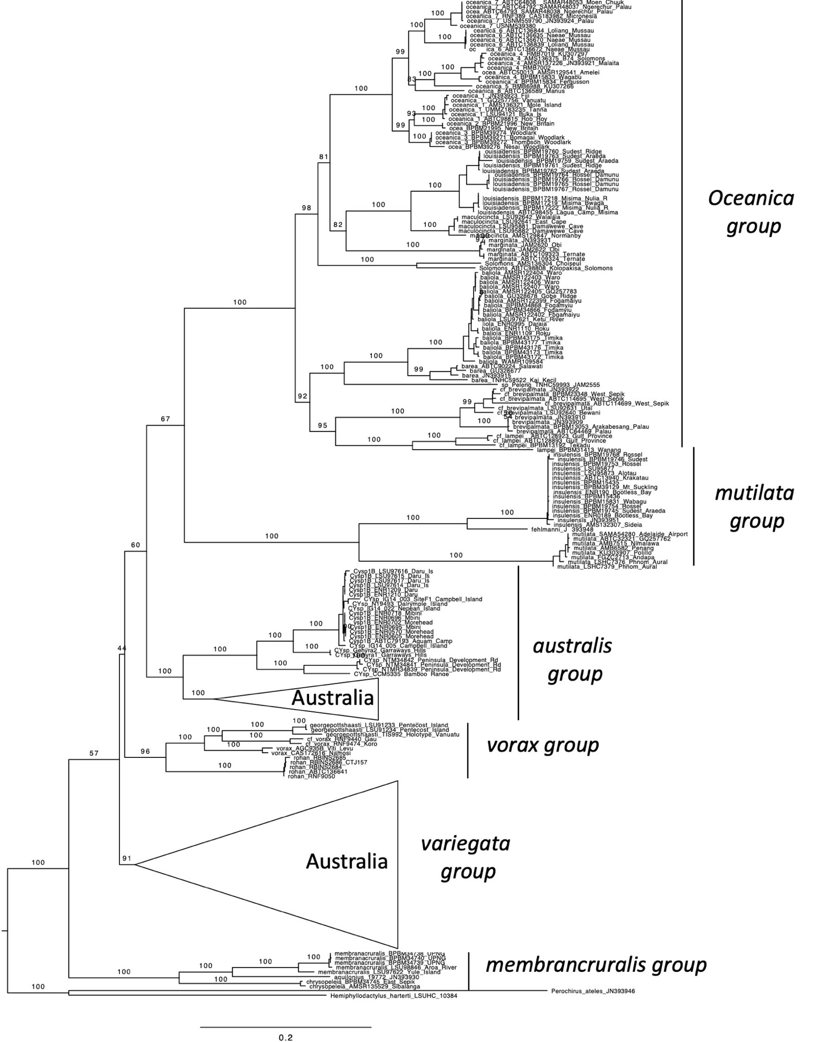

Figure S1. Maximum Likelihood tree estimated using IQtree and showing major species groups and summary of ND2 sampling for Melanesian Gehyra.

Figure S2. Maximum likelihood tree for Gehyra estimated from 100 nuclear loci using RAxML. Details of names on tips are provided in Appendix S2.

Figure S3. Bayesian chronogram for Gehyra estimated using 100 nuclear loci using BEAST and concatenated dataset. Details of tip names are provided in Appendix S2. Root age of tree set to 1. These analyses were run for 100 million generations, sampling every 1000 and with the first 20% of trees discarded as burnin.

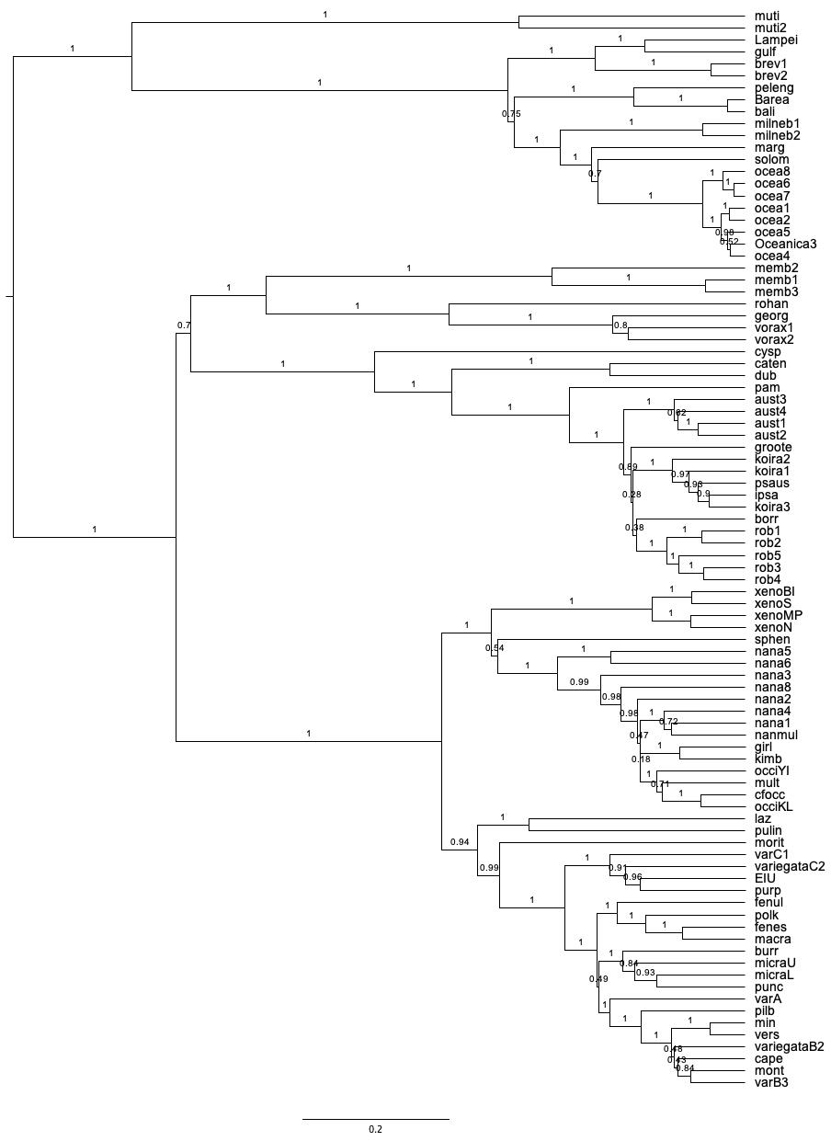
Figure S4. StarBEAST “divide and conquer” tree for Gehyra estimated from 100 loci with support values for all nodes. Tree compiled from skeleton tree and combined with focal analyses on four subgroup trees. Details of tip names are provided in Appendix S2.

Figure S5. Ancestral area estimations for Gehyra based on model with highest AICc value in PhyBears (DEC+J+D=e=D). Number of ancestral states were unconstrained. Region codes are as follows: O = Australia, N = New Guinea, E = East Melanesia, P= Pacific, WA = Wallacea, A = Asia.

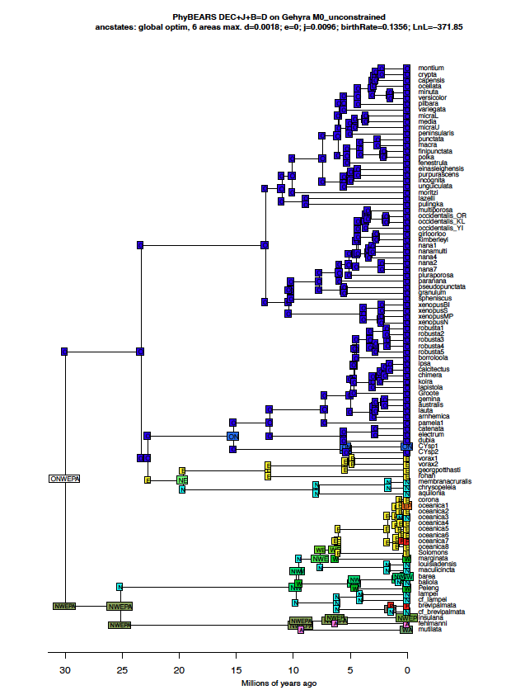
Figure S6. Ancestral area estimations for Gehyra based on model with realistically high extinction rate that could influence biogeographic inference (DEC+J+D+B=D) as implemented in PhyBears. Number of ancestral states were unconstrained. Region codes are as follows: O = Australia, N = New Guinea, E = East Melanesia, P= Pacific, WA = Wallacea, A = Asia.

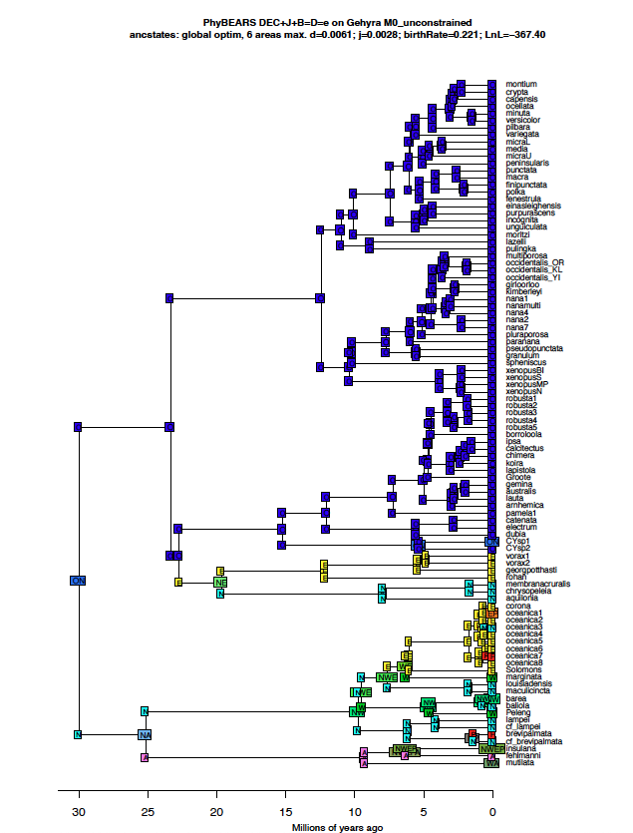
Figure S7. Ancestral area estimations for Gehyra based on model with realistically high extinction rate that could influence biogeographic inference (DEC+J+B=D-e) as implemented in PhyBears. Number of ancestral states were unconstrained. Region codes are as follows: O = Australia, N = New Guinea, E = East Melanesia, P= Pacific, WA = Wallacea, A = Asia.

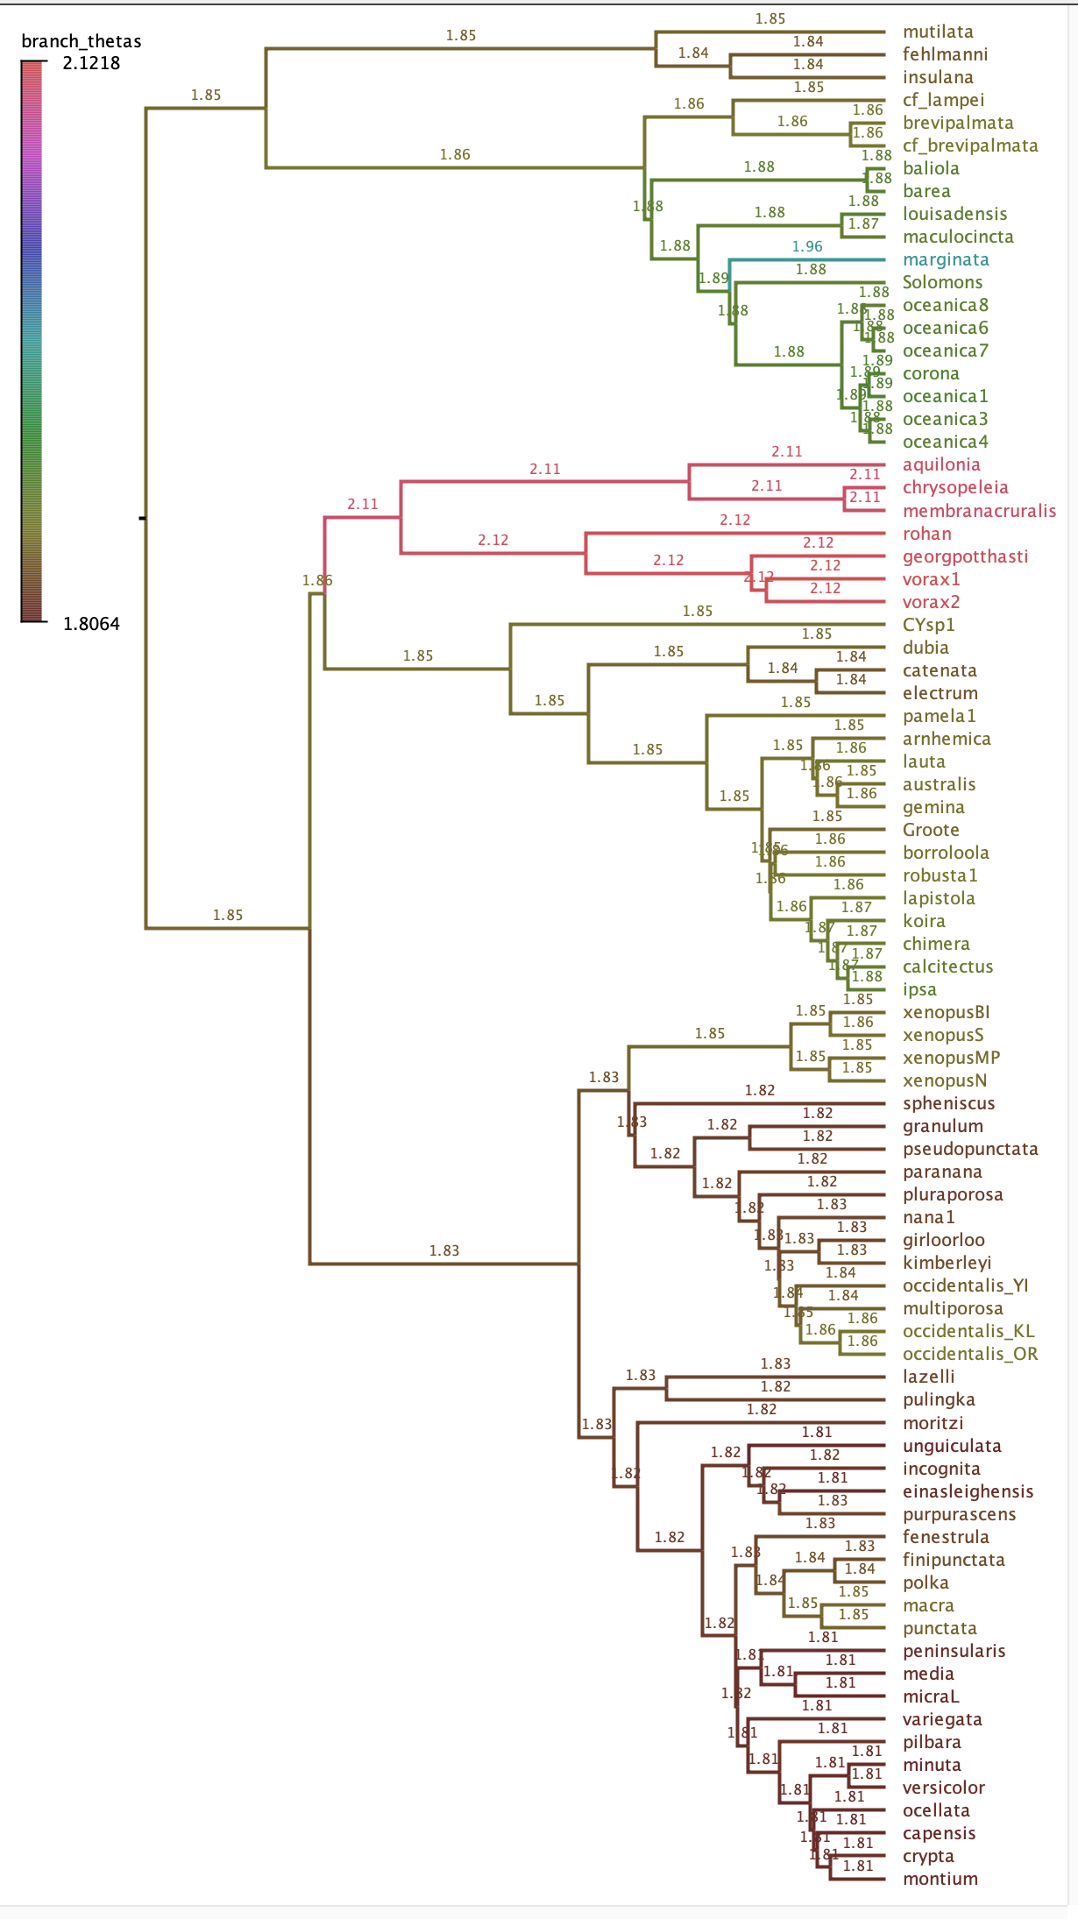

Figure S8. Estimation of values for body-size optima (OU theta parameter) estimated using a relaxed Ornstein–Uhlenbeck (OU) model on StarBEAST “divide and conquer” phylogeny for Gehyra estimated from 100 loci. The clade comprising of the G. membrancruralis and G. vorax groups (bright red branches) from Melanesia has a considerably larger estimated “optimum” size than other clades.

Appendix S1. Summary data for all samples of Melanesian and Pacific Gehyra sequenced as part of this work.

OTU | Exon Cap | CATNUM | Tissue # | FEILDNUM | Genbank | Country | ORIGLOCAL | Latitude | Longitude
aquilonius | memb3 | BPBM19772 | PCMB8351 | FK 9751 | JN393930 | Papua New Guinea | Sudest Island, Araeda | -11.4362 | 153.4301
baliola |  | BPBM34866 |  | AA 19313 | pending | Papua New Guinea | Fogamy`u | -6.5189 | 143.0802
baliola |  | BPBM34868 |  | AA 19586 | pending | Papua New Guinea | Fogamy`u | -6.5189 | 143.0802
baliola |  |  | ABTC98397 | JCU2423 | pending | Papua New Guinea | Gobe Ridge Camp | -6.8235 | 143.7447
baliola |  | AMSR122399 | ABTC44601 |  | pending | Papua New Guinea | Fogamaiyu | -6.5160 | 143.0830
baliola |  | AMSR122402 | ABTC44604 |  | pending | Papua New Guinea | Fogamaiyu | -6.5160 | 143.0830
baliola | bali_3 | AMSR122403 | ABTC44593 |  | pending | Papua New Guinea | Waro | -6.5160 | 143.1830
baliola |  | AMSR122404 | ABTC44485 |  | pending | Papua New Guinea | Waro | -6.5160 | 143.1830
baliola |  | AMSR122405 | ABTC44765 |  | GQ257783 | Papua New Guinea | Waro | -6.5160 | 143.1830
baliola |  | AMSR122406 | ABTC46838 |  | pending | Papua New Guinea | Waro | -6.5160 | 143.1830
baliola |  | AMSR122407 | ABTC46839 |  | pending | Papua New Guinea | Waro | -6.5160 | 143.1830
baliola |  | BPBM43172 |  | AA 15313 | pending | Indonesia | Timika | -4.5417 | 136.8908
baliola |  | BPBM43173 |  | AA 15314 | pending | Indonesia | Timika | -4.5417 | 136.8908
baliola |  | BPBM43175 |  | AA 15316 | pending | Indonesia | Timika | -4.5417 | 136.8908
baliola |  | BPBM43176 |  | AA 15317 | pending | Indonesia | Timika | -4.5417 | 136.8908
baliola |  | BPBM43177 |  | AA 15318 | pending | Indonesia | Timika | -4.5417 | 136.8908
baliola |  | LSUMZ 97621 |  | CCA 16333 | pending | Papua New Guinea | Roku Village | -6.0748 | 141.5235
baliola | bali_2 |  |  | ENR1109 | pending | Papua New Guinea | Roku Village | -8.7029 | 141.5976
baliola | bali_1 |  |  | ENR1110 | pending | Papua New Guinea | Roku Village | -8.7029 | 141.5976
baliola |  |  |  | ENR0995 | pending | Papua New Guinea | Daraia Village | -8.6167 | 141.7333
barea | barea |  | ABTC90224 | SJR7786 | KJ025189 | Indonesia | Waibya Camp, Salawati Island | -0.9564 | 130.7843
barea |  | TNHC59522 |  |  | pending | Indonesia | Kai Kecil | -5.8 | 132.7
barea |  |  | JB24 |  | JN393915 | Captive | Captive | na | na
brevipalmata | brev1_2 | BPBM13053 |  | AA 14451 | pending | Palau [= Belau] | Carolines Resort, Arakabesang Island | 7.3520 | 134.4500
brevipalmata | brev1_1 | SAMA R47727 |  | CCA 1042 | pending | Palau (Republic of) | Jap. Bunker ~5k East of Icebox Park | 7.3225 | 134.4500
brevipalmata |  | USNM 559784 |  |  | JN393909 | Palau | Ngemelachel Island | 7.33 | 134.45
brevipalmata |  | USNM 559786 |  |  | JN393910 | Palau | Ulong Islands | 7.27 | 134.29
cf_brevipalmata |  | LSUMZ 92631 |  | CCA 2904 | pending | Papua New Guinea | Utai Village, ~ 2 km south of airfield | -3.3961 | 141.5829
cf_brevipalmata | brev2_2 | LSUMZ 92640 |  | CCA 3657 | pending | Papua New Guinea | Bewani Station, base of Bewani Mountains | -3.0537 | 141.1668
cf_brevipalmata |  | BPBM23348 | PCMB8888 | FK 11450 | pending | Papua New Guinea | Parkop | -3.4246 | 142.5187
cf_brevipalmata | brev2_1 | BPBM23349 | PCMB9073 | FK 11878 | JN393922 | Papua New Guinea | Sibilanga | -3.4488 | 142.4982
cf_brevipalmata |  |  | ABTC114695 | 13192 | pending | Papua New Guinea | Sio Camp, Frieda River | -4.4039 | 142.2925
cf_brevipalmata |  |  | ABTC114699 | 13200 | pending | Papua New Guinea | Sio Camp, Frieda River | -4.4039 | 142.2925
cf_lampei | gulf_3 | BPBM13192 |  | AA 14568 | pending | Papua New Guinea | Tekadu. | -7.6649 | 146.5639
cf_lampei | gulf_1 |  | ABTC128893 | SJR14337 | pending | Papua New Guinea | Gulf Province | -6.9761 | 144.9921
cf_lampei | gulf_2 |  | ABTC128923 | SJR14378 | pending | Papua New Guinea | Gulf Province | -6.9761 | 144.9921
chrysopeleia |  | AMSR135529 | ABTC50301 |  | pending | Papua New Guinea | near Sibilanga Mission | -3.45 | 142.5
chrysopeleia | memb2_1 | BPBM34745 | PCMB9416 | FK 13301 | pending | Papua New Guinea | East Sepik Prov., Mindangua Stream | -3.60565 | 143.492
CYsp |  | LSUMZ 97614 |  | CCA 16132 | pending | Papua New Guinea | Daru Island; vicinity of Kuki Hotel | -9.0735 | 143.2112
CYsp |  | LSUMZ 97615 |  | CCA 16133 | pending | Papua New Guinea | Daru Island; vicinity of Kuki Hotel | -9.0735 | 143.2112
CYsp |  | LSUMZ 97616 |  | CCA 16134 | pending | Papua New Guinea | Daru Island; vicinity of Kuki Hotel | -9.0735 | 143.2112
CYsp |  | LSUMZ 97617 |  | CCA 16135 | pending | Papua New Guinea | Daru Island; vicinity of Kuki Hotel | -9.0735 | 143.2112
CYsp |  |  |  | ENR0570 | pending | Papua New Guinea | Morehead | -8.7122 | 141.6467
CYsp |  |  |  | ENR0605 | pending | Papua New Guinea | Morehead | -8.7122 | 141.6467
CYsp |  |  |  | ENR0695 | pending | Papua New Guinea | Mibini Village | -8.8389 | 141.6374
CYsp |  |  |  | ENR0696 | pending | Papua New Guinea | Mibini Village | -8.8389 | 141.6374
CYsp |  |  |  | ENR0702 | pending | Papua New Guinea | Mibini Village | -8.8079 | 141.6619
CYsp |  |  |  | ENR0718 | pending | Papua New Guinea | Mibini Village | -8.8079 | 141.6619
CYsp |  |  |  | ENR1209 | pending | Papua New Guinea | Daru Island; Kuki Hotel | -9.0735 | 143.2112
CYsp |  |  |  | ENR1210 | pending | Papua New Guinea | Daru Island; Kuki Hotel | -9.0735 | 143.2112
CYsp |  |  | ABTC79193 | SJR3579 | pending | New Guinea | Aquam Camp | -9.0967 | 141.4356
fehlmani |  |  | TG 00723 |  | JN393948 | Malaysia | Captive | na | na
georgepottshaasti | georg_2 | LSUMZ 91235 |  | CCA 6223 | pending | Vanuatu | Espiritu Santo Island; Village of Tasariki | -15.6114 | 166.7808
georgepottshaasti | georg_1 | LSUMZ 91233 |  | CCA 6633 | pending | Vanuatu | Pentecost Island; Lamalana village area | -15.4744 | 169.1703
georgepottshaasti |  | LSUMZ 91234 |  | CCA 6634 | pending | Vanuatu | Pentecost Island; Lamalana village area | -15.4606 | 168.1539
georgepottshaasti |  | ZFMK91004 | TIS992 |  | pending | Vanuatu | Dudun Island, off coast of Mare | -21.36 | 167.73
insulensis |  | BPBM15435 | PCMB6867 | FK 5577 | pending | Papua New Guinea | Duabo, Pini Range | -10.4184 | 150.307
insulensis |  | BPBM15436 | PCMB6868 | FK 5578 | pending | Papua New Guinea | Duabo, Pini Range | -10.4184 | 150.307
insulensis |  | BPBM15831 | PCMB6974 | FK 5778 | pending | Papua New Guinea | Wagabu Is | -9.3374 | 150.688
insulensis |  | BPBM19745 | PCMB8259 | FK 9451 | pending | Papua New Guinea | Sudest Island, Araeda | 11.4362 | 153.4301
insulensis |  | BPBM19746 | PCMB8260 | FK 9452 | pending | Papua New Guinea | Sudest Island, Araeda | 11.4362 | 153.4301
insulensis |  | BPBM19753 | PCMB8431 | FK 10013 | pending | Papua New Guinea | Rossel Island, Damunu | -11.365 | 154.001
insulensis |  | BPBM19754 | PCMB8432 | FK 10014 | pending | Papua New Guinea | Rossel Island, Damunu | -11.365 | 154.001
insulensis |  | BPBM39129 | PCMB10265 | FK 15752 | pending | Papua New Guinea | Yamsiai, base of Mt. Suckling | -9.6708 | 148.278
insulensis |  | LSUMZ 95873 |  | CCA 4350 | pending | Papua New Guinea | Alotau | -10.3059 | 150.4372
insulensis |  | LSUMZ 95877 |  | CCA 4447 | pending | Papua New Guinea | Lookout "Duabo" Pini Range | -10.4179 | 150.3069
insulensis |  |  |  | ENR0189 | pending | Papua New Guinea | Bootless Bay | -9.5093 | 147.2902
insulensis |  |  |  | ENR0190 | pending | Papua New Guinea | Bootless Bay | -9.5093 | 147.2902
insulensis |  | BPBM19768 | PCMB8442 | FK 10046 | pending | Papua New Guinea | Rossel Island, Cheme | -11.3231 | 154.2429
insulensis |  | AMSR132305 |  |  | JN393951 | Papua New Guinea | Normanby Island | -10.1 | 151.25
insulensis |  | AMSR132307 |  |  | pending | Papua New Guinea | Sideia Island | -10.533 | 150.8
insulensis | muti2 |  | ABTC13940 |  | GQ257784 | Indonesia | Krakatau | -6.1 | 105.4
lampei | lamp_1 | BPBM31413 |  | AA 18928 | pending | Papua New Guinea | Wanang | -5.2322 | 145.1807
louisiadensis |  |  | ABTC98455 | 2677 | pending | Papua New Guinea | Lagua Camp, Misima Island | -10.6946 | 152.8288
louisiadensis |  | BPBM17218 | PCMB7314 | FK 6864 | pending | Papua New Guinea | Misima Island, Nulia R., Liak | -10.6608 | 152.685
louisiadensis | milneb_1 | BPBM17219 | PCMB7345 | FK 6951 | pending | Papua New Guinea | Misima Island, Bwaga Bwaga Ridge | -10.674 | 152.683
louisiadensis |  | BPBM17221 | PCMB7393 | FK 7035 | pending | Papua New Guinea | Misima Island, along Nulia River, Liak | -10.6608 | 152.685
louisiadensis |  | BPBM17222 | PCMB7394 | FK 7036 | pending | Papua New Guinea | Misima Island, along Nulia River, Liak | -10.6608 | 152.685
louisiadensis |  | BPBM19759 | PCMB8258 | FK 9450 | pending | Papua New Guinea | Sudest Island, Araeda | -11.4362 | 153.4301
louisiadensis |  | BPBM19760 | PCMB8370 | FK 9869 | pending | Papua New Guinea | Sudest Island, ridge N of Camp 1. | -11.4918 | 153.4126
louisiadensis | milneb_2 | BPBM19761 | PCMB8371 | FK 9870 | pending | Papua New Guinea | Sudest Island, ridge N of Camp 1. | -11.4918 | 153.4126
louisiadensis |  | BPBM19762 | PCMB8386 | FK 9892 | pending | Papua New Guinea | Sudest Island, Araeda | -11.4362 | 153.4301
louisiadensis |  | BPBM19763 | PCMB8387 | FK 9893 | pending | Papua New Guinea | Sudest Island, Araeda | -11.4362 | 153.4301
louisiadensis |  | BPBM19764 | PCMB8427 | FK 10009 | pending | Papua New Guinea | Rossel Island, Damunu | -11.365 | 154.001
louisiadensis |  | BPBM19765 | PCMB8428 | FK 10010 | pending | Papua New Guinea | Rossel Island, Damunu | -11.365 | 154.001
louisiadensis |  | BPBM19766 | PCMB8429 | FK 10011 | pending | Papua New Guinea | Rossel Island, Damunu | -11.365 | 154.001
louisiadensis | milneb_3 | BPBM19767 | PCMB8430 | FK 10012 | pending | Papua New Guinea | Rossel Island, Damunu | -11.365 | 154.001
maculocincta |  | AMSR129847 | ABTC49805 |  | GQ257785 | Papua New Guinea | Guleguleu, Normanby Island | -10.1 | 151.25
maculocincta | milneb_5 | LSUMZ 95881 |  | CCA 5149 | pending | Papua New Guinea | Gili Gili Oil Palm Estates | -10.2895 | 150.3045
maculocincta |  | LSUMZ 95882 |  | CCA 5150 | pending | Papua New Guinea | Gili Gili Oil Palm Estates | -10.2895 | 150.3045
maculocincta |  | LSUMZ 92641 |  | CCA 4227 | pending | Papua New Guinea | Eastern tip of East Cape | -10.2301 | 150.8745
maculocincta | milneb_4 | LSUMZ 92642 |  | CCA 4248 | pending | Papua New Guinea | Walalaia, south coast of East Cape | -10.2737 | 150.7903
marginata | marg_1 | MZB7666 | ABTC109323 | T104 | pending | Indonesia | Ternate | 0.8000 | 127.3000
marginata |  | MZB7667 | ABTC109324 | T105 | pending | Indonesia | Ternate | 0.8000 | 127.3000
marginata |  |  |  | JAM2620 | pending | Indonesia | Obi Island, Sulawesi | -1.6 | 127.6000
marginata | marg_2 |  |  | JAM2622 | pending | Indonesia | Obi Island, Sulawesi | -1.6 | 127.6000
marginata |  | MVZ230104 |  |  | JN393931 | Captive | Captive | na | na
membranacruralis | memb1_2 | LSUMZ 98846 |  | CCA 17312 | pending | Papua New Guinea | Ageviru Station, west bank of Aroa River | -9.0204 | 146.8172
membranacruralis | memb1_1 | BPBM34738 | PCMB9354 | FK 13209 | pending | Papua New Guinea | UPNG | -9.4079 | 147.17
membranacruralis |  | BPBM34739 | PCMB9355 | FK 13210 | pending | Papua New Guinea | UPNG | -9.4079 | 147.17
membranacruralis |  | BPBM34740 | PCMB9356 | FK 13211 | pending | Papua New Guinea | UPNG | -9.4079 | 147.17
membranacruralis |  | LSUMZ 97622 |  | CCA 16530 | pending | Papua New Guinea | Yule Island; vicinity of Siria village | -8.8287 | 146.5287
multilata |  |  | AMB7515 | AMB7515 | JN19082 | Sri Lanka | Nimalawa | 6.1 | 80.4
multilata |  | KU303907 |  |  | JN393952 | Philippines | Polillo | 14.7 | 121.9
multilata |  | FGZC 2713 |  |  | JN393953 | Madagascar | Andapa | -14.6 | 49.6
multilata |  |  | AMB 6582 | AMB 6582 | JN393917 | Malaysia | Penang | 5.4 | 100.3
multilata |  | LSHC 7379 |  |  | JN393914 | Cambodia | Phnum Aural | 12.03 | 104.17
multilata |  | LSHC 7376 |  |  | JN393913 | Cambodia | Phnum Aural | 12.03 | 104.17
multilata |  | SAMAR54280 | ABTC73304 |  | pending | Australia | Adelaide Airport, waif | -34.9462 | 138.5312
multilata | muti1 |  | ABTC32321 | CM320 | GQ257762 | Philippines | Negros Island | 0.31028 | 123.30806
oceanica_1 | ocea1_1 |  | ABTC98815 | SJR5567 |  | Solomon Islands | Choiseul, Rob Roy | -7.3925 | 157.5972
oceanica_1 | ocea1_3 | UMMZ182803 | ABTC32281 |  | GQ257756 | Vanuatu | Tanna Island | -19.5300 | 169.5300
oceanica_1 |  | UMMZ183235 | ABTC32293 |  |  | Vanuatu | Tanna Island | -19.5300 | 169.5300
oceanica_1 | ocea1_2 | LSUMZ 94121 |  | CCA 2718 |  | Papua New Guinea | Buka Island, Nova Area | -5.3893 | 154.6518
oceanica_1 |  | USNM333421 |  |  | JN393923 | Fiji | Kaduvu | -18.968 | 178.452
oceanica_1 |  | AMSR136321?? |  |  |  | Solomon Islands | Mole Island | -6.8308 | 156.5181
oceanica_2 |  | BPBM21995 | PCMB8746 | FK 11191 |  | Papua New Guinea | New Britain, Marmar | -5.5190 | 151.5018
oceanica_2 | ocea2_1 | BPBM21996 | PCMB8784 | FK 11326 |  | Papua New Guinea | New Britain, Ulege | -5.5196 | 151.4994
oceanica_3 | ocea3_1 | BPBM39271 | PCMB9928 | FK 14797 |  | Papua New Guinea | Bomagai Camp,, Woodlark Island | -9.1192 | 152.7515
oceanica_3 |  | BPBM39272 | PCMB9944 | FK 14829 |  | Papua New Guinea | Bomagai Camp,, Woodlark Island | -9.1559 | 152.7430
oceanica_3 |  | BPBM39274 | PCMB9959 | FK 14893 |  | Papua New Guinea | Bomagai Camp,, Woodlark Island | -9.1222 | 152.7535
oceanica_3 | ocea3_2 | BPBM39276 | PCMB9980 | FK 14970 |  | Papua New Guinea | Woodlark Island, Wend Nesai Is. | -9.1756 | 152.7434
oceanica_4 |  | BPBM15833 | PCMB6973 | FK 5777 |  | Papua New Guinea | Wagabu Is., S side | -9.3374 | 150.688
oceanica_4 | ocea4_4 | BPBM15834 | PCMB7112 | FK 6242 |  | Papua New Guinea | Fergusson Is., Basima | -9.4683 | 150.832
oceanica_4 |  | AMSR129541 | ABTC50013 |  |  | Papua New Guinea | Amelei | -6.1 | 150.616
oceanica_4 |  | AMSR136375 | ABTC50477 |  |  | Solomon Islands | Honiara, Guadalcanal | -9.433 | 159.95
oceanica_4 | ocea4_2 | KU307280 | RMB7002 |  |  | Solomon Islands | Honiara, Guadalcanal | -9.433 | 159.95
oceanica_4 |  | AMSR137226 |  |  | JN393921 | Solomon Islands | Malaita | -8.816 | 160.816
oceanica_4 | ocea4_3 | KU307297 | RMB7019 |  |  | Solomon Islands | Guadacanal Island | -9.4754 | 160.1746
oceanica_4 | ocea4_1 | AMSR136375 | B74 |  |  | Solomon Islands | Honiara, Guadalcanal | -9.433 | 159.95
oceanica_5 | ocea5_1 | KU307266 | RMB6988 |  |  | Solomon Islands | Ranongga Island | -8.0821 | 156.5996
oceanica_6 |  |  | ABTC136635 | SJR15099 |  | Papua New Guinea | Naeae, Mussau Island | -1.504 | 149.731
oceanica_6 | ocea6_1 |  | ABTC136670 | SJR15135 |  | Papua New Guinea | Naeae, Mussau Island | -1.504 | 149.731
oceanica_6 |  |  | ABTC136672 | SJR15137 |  | Papua New Guinea | Naeae, Mussau Island | -1.504 | 149.731
oceanica_6 | ocea6_2 | MA170 | ABTC136839 | MA170 |  | Papua New Guinea | Loliang, Mussau Island | -1.5 | 149.611
oceanica_6 |  | MA175 | ABTC136844 | MA175 |  | Papua New Guinea | Loliang, Mussau Island | -1.422 | 149.51
oceanica_7 |  | USNM539380 |  |  |  | Palau | Fanna Island | 5.3527 | 132.2282
oceanica_7 |  | USNM559790 |  |  | JN393924 | Palau |  | 7.34 | 134.56
oceanica_7 | ocea7_2 | CAS183982 | RNF389 |  |  | Micronesia | Pohnpei | 6.96 | 158.21
oceanica_7 |  | SAMAR48037 | ABTC64792 | CCA1398 |  | Palau | Ngerechur Island, 2k N Babeldaob Island | 7.75 | 134.62
oceanica_7 |  | SAMAR48038 | ABTC64793 | CCA1399 |  | Palau | Ngerechur Island, 2k N Babeldaob Island | 7.75 | 134.62
oceanica_7 |  | SAMAR48053 | ABTC64808 | CCA1420 |  | Micronesia | Moen Island, Chuuk | 7.4292 | 151.8444
oceanica_8 | ocea8_1 |  | ABTC136589 | SJR14237 |  | Papua New Guinea | Piri Village, Manus Island | -2.21 | 146.96
rohan | rohan_2 | CAS252881 |  | RNF9050 | KX954302 | New Guinea | Manus Island | -2.0415 | 147.2594
rohan | rohan_1 | SAMAR69881 |  | SJR15105 | KX954303 | New Guinea | Mussau | -1.5240 | 149.7390
rohan |  | RBINS2686 |  | CTJ157 | KX954304 | New Guinea | Yiringou | -2.0833 | 147.1167
rohan |  | RBINS2684 |  | CTJ088 | KX954301 | New Guinea | Near Lorengau | -2.0388 | 147.2370
rohan |  | RBINS2685 |  | CTJ158 | KX954300 | New Guinea | Yiringou | -2.0833 | 147.1167
Solomons | solomons |  | ABTC98808 | SJR5487 |  | Solomon Islands | Santa Isabel, Kolopakisa | -7.59 | 158.64
Solomons |  | AMSR136304 | ABTC50349 |  |  | Solomon Islands | Pavora River, Choiseul Island | -6.766 | 156.533
sp Peleng | peleng |  |  | JAM2555 |  | Indonesia | Peleng Island, Sulawesi | -1.3 | 123.0000
vorax1 | vorax1_2 | CAS172616 |  | RNF9804 | KX954305 | Fiji | Namosi | -18.0414 | 178.1325
vorax1 | vorax1_1 |  |  | AGC935B |  | Fiji | Viti Levu | -18.07796 | 177.8225
vorax2 | vorax_2 |  |  | RNF9474 |  | Fiji | Koro | -17.294 | 179.392
vorax2 | vorax2_1 |  |  | RNF9440 |  | Fiji | Gau | -18.0453 | 179.3037

Appendix S2. Details of samples included in exon capture based analyses. Tip label corresponds to individual sample name and matches with names in trees estimated using concatenation methods (Figures S2-3). Species/OTU corresponds to names used in coalesecent trees (Figures 2-3, S4-6). Highlighted samples are divergent lineages were haplotypes 1 and 2 were included in coalescent analyses.

Species group | Tip label | Species/OTU | Voucher# | Tissue#/Field#
australis grp | aust1_1 | gemina | WAMR172043 | ABTC105797
australis grp | aust1_2 | gemina |  | CCM2220
australis grp | aust2_1 | australis |  | CCM2943
australis grp | aust2_2 | australis | NTMR21022 | ABTC28970
australis grp | aust3_1 | arnhemica |  | 4:W02 - AWC
australis grp | aust3_2 | arnhemica |  | CCM2408
australis grp | aust4_1 | lauta |  | CCM0322
australis grp | aust4_2 | lauta |  | CCM0438
australis grp | borr_1 | borroloola | NTMR37944 | CCM2577
australis grp | borr_2 | borroloola | NTMR38022 | CCM2689
australis grp | caten_1 | catenata | SAMAR55893 | ABTC77213
australis grp | caten_2 | catenata | SAMAR55893 | ABTC77213
australis grp | cysp_1 | CYsp1 |  | Gehyra1 - JCU (Hoskin)
australis grp | cysp_2 | CYsp1 |  | ABTC79193
australis grp | dub_1 | dubia |  | CCM0346
australis grp | dub_2 | dubia |  | Geck1 - JCU (Hoskin)
australis grp | groote_1 | Groote |  | CCM3733
australis grp | groote_2 | Groote |  | CCM3733
australis grp | ipsa_1 | ipsa | WAMR177671 | CCM3211
australis grp | ipsa_2 | ipsa | WAMR177670 | CCM3210
australis grp | koira1_1 | koira | NTMR34709 | Z22602
australis grp | koira1_2 | koira | NTMR36577 | CMNT51
australis grp | koira2_1 | lapistola | NTMR35099 | Z22598
australis grp | koira2_2 | lapistola |  | CCM2935
australis grp | koira3_1 | calcitectus | WAMR177693 | CCM3259
australis grp | koira3_2 | calcitectus | WAMR177695 | CCM3333
australis grp | pam_1 | pamela |  | CCM0473
australis grp | pam_2 | pamela | MVD72592 | Z18888
australis grp | psaus_1 | chimera |  | CCM1097
australis grp | psaus_2 | chimera | WAMR167806 | WAMR167806
australis grp | rob1_1 | robusta 1 |  | CCM0263
australis grp | rob1_2 | robusta 1 |  | CCM0330
australis grp | rob2_1 | robusta 2 | NTMR38011 | CCM0366
australis grp | rob2_2 | robusta 2 | NTMR38011 | CCM0366
australis grp | rob3_1 | robusta 3 |  | CCM0271
australis grp | rob3_2 | robusta 3 |  | CCM0290
australis grp | rob4_1 | robusta 4 |  | CCM0280
australis grp | rob4_2 | robusta 4 |  | CCM0281
australis grp | rob5_1 | robusta 5 | SAMAR42699 | ABTC8949
australis grp | rob5_2 | robusta 5 |  | CCM0239
membranacruralis grp | memb1_1 | membranacruralis 1 | BPBM34738
membranacruralis grp | memb1_2 | membranacruralis 1 | LSU98846
membranacruralis grp | memb2_1 | chrysopeleia | BPBM34745
membranacruralis grp | memb2_2 | chrysopeleia | BPBM34745
membranacruralis grp | memb3_1 | aquilonius | BPBM19772
membranacruralis grp | memb3_2 | aquilonius | BPBM19772
mutilata grp | muti_1 | mutilata |  | ABTC32321/CM320
mutilata grp | muti2_1 | insulana | SAMAR35716 | ABTC13940_
mutilata grp | muti2_2 | insulana | SAMAR35716 | ABTC13940_
oceanica grp | bali_1 | baliola |  | ENR1110
oceanica grp | bali_2 | baliola | AMSR122403 | ABTC44593
oceanica grp | barea | barea |  | ABTC90224 / SJR7786
oceanica grp | brev1_1 | brevipalmata |  | ABTC64662
oceanica grp | brev1_2 | brevipalmata | BPBM13053 | AA14451
oceanica grp | brev2_1 | cf brevipalmata | BPBM23349 | FK11878
oceanica grp | brev2_2 | cf brevipalmata | LSUMZ92640 | CCA3657
oceanica grp | gulf_1 | cf lampei |  | ABTC128893/ SJR14337
oceanica grp | gulf_2 | cf lampei | BPBM13192 | AA14586
oceanica grp | lamp | lampei | BPBM31413 | AA18928
oceanica grp | marg_1 | marginata | MZB7666 | ABTC109323 /T104
oceanica grp | marg_2 | marginata |  | JAM2622
oceanica grp | milneb1_1 | louisadensis | BPBM17219 | FK6951
oceanica grp | milneb1_2 | louisadensis | BPBM19767 | FK10012
oceanica grp | milneb2_1 | maculocincta | LSUMZ92642
oceanica grp | milneb2_2 | maculocincta | LSUMZ95881 | CCA5149
oceanica grp | ocea1_1 | oceanica 1 |  | ABTC98815/SJR5567
oceanica grp | ocea1_2 | oceanica 1 | UMMZ182803 | ABTC32281
oceanica grp | ocea2_1 | oceanica 2 | BPBM21996
oceanica grp | ocea2_2 | oceanica 2 | BPBM21996
oceanica grp | ocea3 | oceanica 3 | BPBM39271 | FK14797
oceanica grp | ocea4_1 | oceanica 4 |  | RMB7019
oceanica grp | ocea4_2 | oceanica 4 | BPBM15834
oceanica grp | ocea5_1 | oceanica 5 |  | RMB6988
oceanica grp | ocea5_2 | oceanica 5 |  | RMB6988
oceanica grp | ocea6_1 | oceanica 6 |  | ABTC136670
oceanica grp | ocea6_2 | oceanica 6 |  | ABTC136839/MA170
oceanica grp | ocea7_1 | oceanica 7 |  | RNF389
oceanica grp | ocea7_2 | oceanica 7 | USNM539380
oceanica grp | ocea8_1 | oceanica 8 |  | ABTC136589/ SJR14237
oceanica grp | ocea8_2 | oceanica 8 |  | ABTC136589/ SJR14237
oceanica grp | peleng_1 | Peleng |  | JAM2555
oceanica grp | peleng_2 | Peleng |  | JAM2555
oceanica grp | solom_1 | Solomons |  | ABTC98808/SJR5487
oceanica grp | solom_2 | Solomons |  | ABTC98808/SJR5487
variegata grp | burr_1 | peninsularis | WAMR132563
variegata grp | burr_2 | Peninsularis | WAMR165508
variegata grp | cape_1 | capensis | WAMR123947
variegata grp | cape_2 | capensis | WAMR153818
variegata grp | cfocc_1 | occidentalis_OR |  | PMO186
variegata grp | cfocc_2 | occidentalis_OR |  | PMO193
variegata grp | EIU_1 | einasleighensis | SAMAR55786 | ABTC77093
variegata grp | EIU_2 | einasleighensis | QMJ94585 | A013584/CCM0069
variegata grp | fenes_1 | punctata | WAMR116893
variegata grp | fenes_2 | punctata | WAMR129932
variegata grp | fenul_1 | fenestrula | WAMR114335
variegata grp | fenul_2 | fenestrula | WAMR129925
variegata grp | girl_1 | girloorloo | WAMR113727
variegata grp | girl_2 | girloorloo | WAMR175047 | CCM3327
variegata grp | kimb_1 | kimberleyi | WAMR176229 | CCM1361
variegata grp | kimb_2 | kimberleyi | WAMR175035 | CCM1332
variegata grp | laz_1 | lazelli | SAMAR64431
variegata grp | laz_2 | lazelli | SAMAR38950 | ABTC15181
variegata grp | macra_1 | macra | WAMR162701
variegata grp | macra_2 | macra | WAMR160096
variegata grp | micraL_1 | micraL | WAMR131008
variegata grp | micraL_2 | micraL | WAMR158267
variegata grp | micraU_1 | micraU | WAMR110013
variegata grp | micraU_2 | micraU | WAMR141332
variegata grp | min_1 | minuta |  | CCM1930
variegata grp | min_2 | minuta | NTMR38017 | CCM2774
variegata grp | mont_1 | montium | WAMR131737 | ABTC105323
variegata grp | mont_2 | montium | WAMR145513
variegata grp | morit_1 | moritzi | QMJ90245 | A007723
variegata grp | morit_2 | moritzi | NTMR37969 | CCM2772
variegata grp | mult_1 | multiporosa | WAMR168148 | ABTC105353
variegata grp | mult_2 | multiporosa | WAMR168579 | BP01201
variegata grp | nana1_1 | nana 1 | MVD77038
variegata grp | nana1_2 | nana 1 | WAMR176392 | CCM1787
variegata grp | nana2_1 | nana 2 | NTMR37090
variegata grp | nana2_2 | nana 2 |  | CCM3548
variegata grp | nana3_1 | paranana | NTMR37831 | CCM0651
variegata grp | nana3_2 | paranana | NTMR37056
variegata grp | nana4_1 | nana 4 | WAMR171085
variegata grp | nana4_2 | nana 4 | WAMR173130
variegata grp | nana5_1 | pseudopunctata | WAMR176239 | CCM1441
variegata grp | nana5_2 | pseudopunctata | WAMR176289 | CCM1826
variegata grp | nana6_1 | granulum | WAMR176205 | CCM1210
variegata grp | nana6_2 | granulum | WAMR165439
variegata grp | nana8_1 | pluraporosa | WAMR174026
variegata grp | nana8_2 | pluraporosa | WAMR174024
variegata grp | nanmul_1 | nanamulti | WAMR172824
variegata grp | nanmul_2 | nanamulti | WAMR174051
variegata grp | occiKL_1 | occidentalis_KL | WAMR164773 | ABTC105371
variegata grp | occiKL_2 | occidentalis_KL | WAMR172143 | ABTC112804/BP02107
variegata grp | occiYI_1 | occidentalis_YI | WAMR114452 | ABTC105356
variegata grp | occiYI_2 | occidentalis_YI | WAMR172075 | BP01522
variegata grp | pilb_1 | pilbara | NTMR22786 | ABTC30160
variegata grp | pilb_2 | pilbara | WAMR102167
variegata grp | polk_1 | finipunctata | WAMR123764
variegata grp | polk_2 | finipunctata | WAMR139444
variegata grp | pulin_1 | pulingka | SAMAR50119 | ABTC42130
variegata grp | pulin_2 | pulingka | SAMAR54751 | ABTC73410
variegata grp | punc_1 | media | WAMR110146
variegata grp | punc_2 | media | WAMR114571
variegata grp | purp_1 | purpurascens |  | CCM1919
variegata grp | purp_2 | purpurascens | NTMR37938 | CCM2762
variegata grp | sphen_1 | spheniscus |  | CCM2821
variegata grp | sphen_2 | spheniscus | WAMR171592
variegata grp | varA_1 | variegata | WAMR120033
variegata grp | varA_2 | variegata | WAMR117025 | ABTC105564
variegata grp | varB2 | ocellata | WAMR165744
variegata grp | varB3_1 | crypta | WAMR119017 | ABTC105571
variegata grp | varB3_2 | crypta | WAMR170800 | ABTC105651
variegata grp | varC1_1 | unguiculata | WAMR156584
variegata grp | varC1_2 | unguiculata | WAMR161412
variegata grp | varC2 | incognita | WAMR145555
variegata grp | vers_1 | versicolor | NTMR21507 | ABTC29513
variegata grp | vers_2 | Versicolor | SAMAR38945 | ABTC3671
variegata grp | xenoBI_1 | xenopusBI | WAMR164925 | ABTC105670
variegata grp | xenoBI_2 | xenopusBI | WAMR168217
variegata grp | xenoMP_1 | xenopusMP | WAMR138892 | ABTC105662
variegata grp | xenoMP_2 | xenopusMP | WAMR171589
variegata grp | xenoN_1 | xenopusN | WAMR113993
variegata grp | xenoN_2 | xenopusN | WAMR175485 | CCM0941
variegata grp | xenoS_1 | xenopusS | WAMR171492
variegata grp | xenoS_2 | xenopusS | WAMR168548 | BP01207
vorax grp | georg_1 | georgpotthasti | LSUMZ91233 | CCA6633
vorax grp | georg_2 | georgpotthasti | LSU91235
vorax grp | rohan_1 | rohan |  | ABTC136641
vorax grp | rohan_2 | rohan |  | RNF9050
vorax grp | vorax1_1 | vorax 1 |  | RNF9440
vorax grp | vorax1_2 | vorax 1 |  | RNF9474
vorax grp | vorax2_1 | vorax 2 |  | AGC935B
vorax grp | vorax2_2 | vorax 2 |  | RNF9804

